SBIT TRAINING ACADEMY

SUBMITTED TO MR.KARTHI GEYAN
IN PARTIAL FULFILLMENT
OF THE REQUIREMENTS FOR THE COURSE

AW421
REACT JS
IN CANDIDACY FOR THE
DEGREE IN SOFTWARE ENGINEERING
BY
Tan Jia Yong
17/11/2025

Contents
Introduction 1
Project Background 1
Proposed System and Objectives 1
Design Outline 2
School Information System React Design Outline 2
Output 4
School Information System React Design Output 4
Development Coding 6
Coding 6
Testing 7
User Guide 8
Conclusion 9
References 10

Introduction

The School Information System (SIS) is a web-based application that helps manage and organize school data efficiently. It allows users to manage information about students, teachers, courses, and grades. Built with ReactJS, the system provides a user-friendly interface with form validation to ensure data accuracy and reliability.

Project Background

Schools often face challenges in managing large amounts of student and teacher data using traditional methods. To improve efficiency and reduce errors, the School Information System (SIS) was created. This web-based platform helps organize and manage school records digitally, making data access, updates, and monitoring faster and more accurate.

Proposed System and Objectives

The proposed system is a web-based School Information System (SIS) that allows users to manage school data easily through an online platform. It includes features to add, edit, delete, and view information about students, teachers, courses, and grades. The system is built using ReactJS to provide a responsive and user-friendly interface with form validation to ensure accurate data entry.

Design Outline

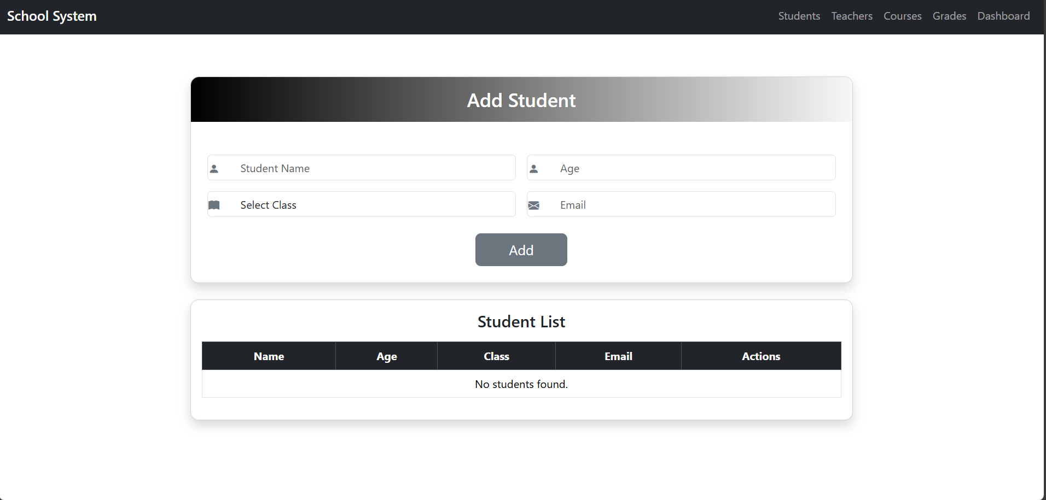

Output (Example)
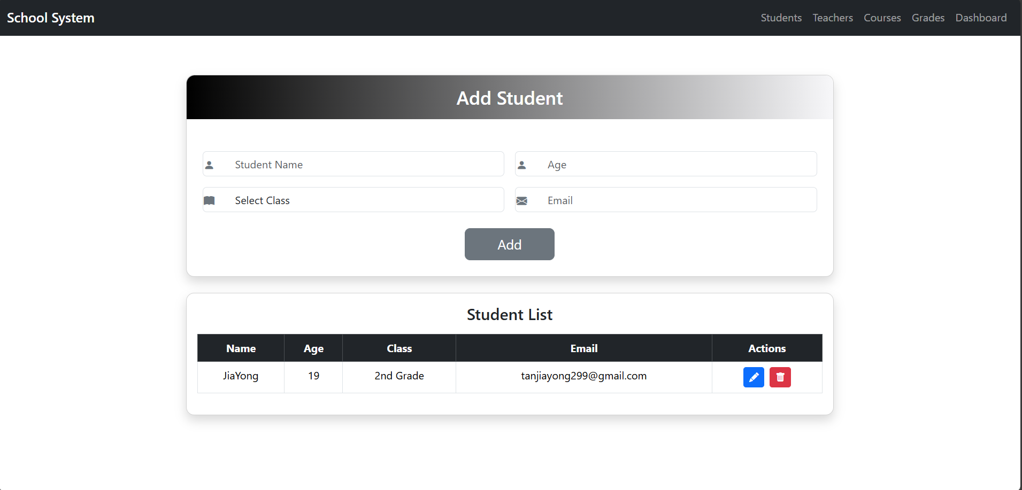
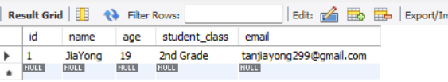

Design Outline
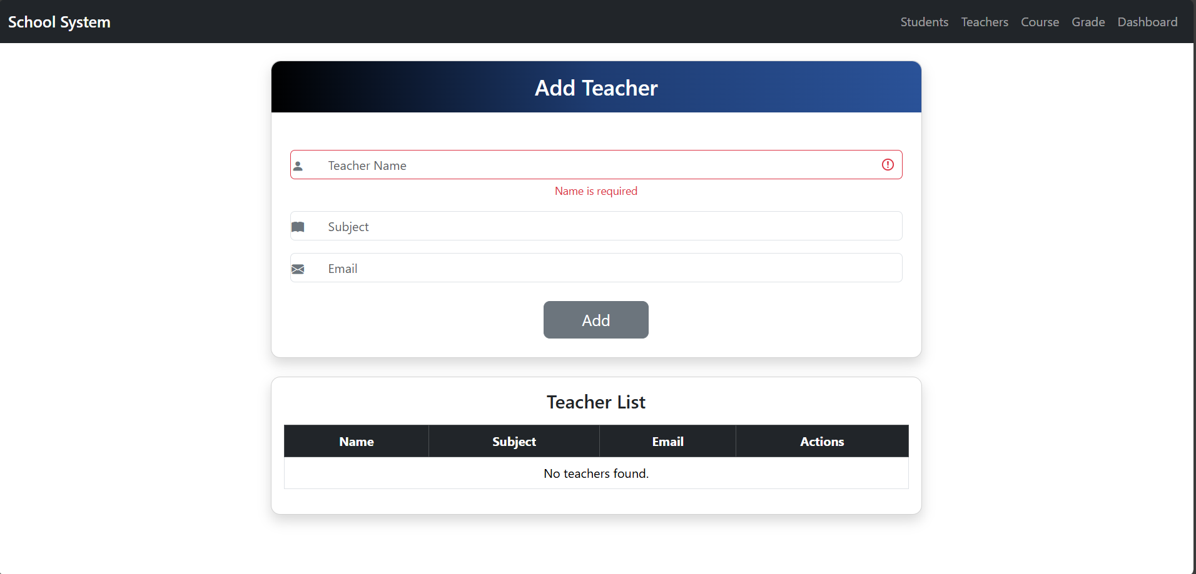

Output (Example)
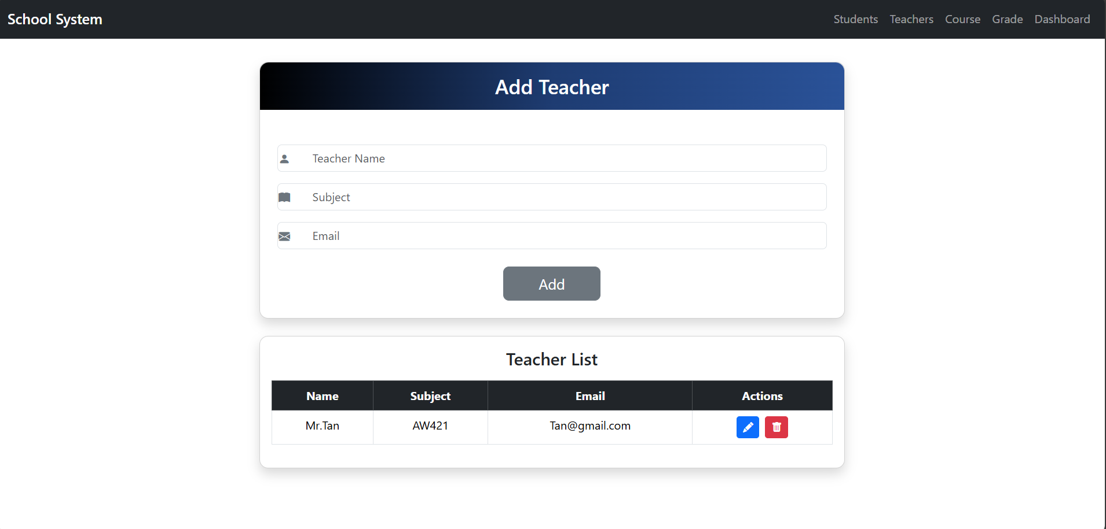
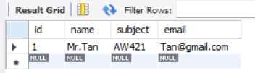

Design Outline
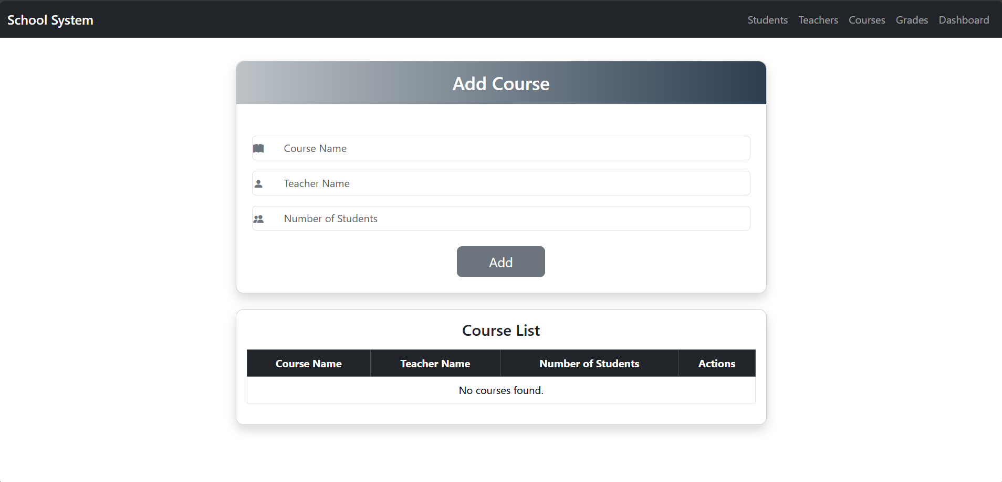

Output (Example)
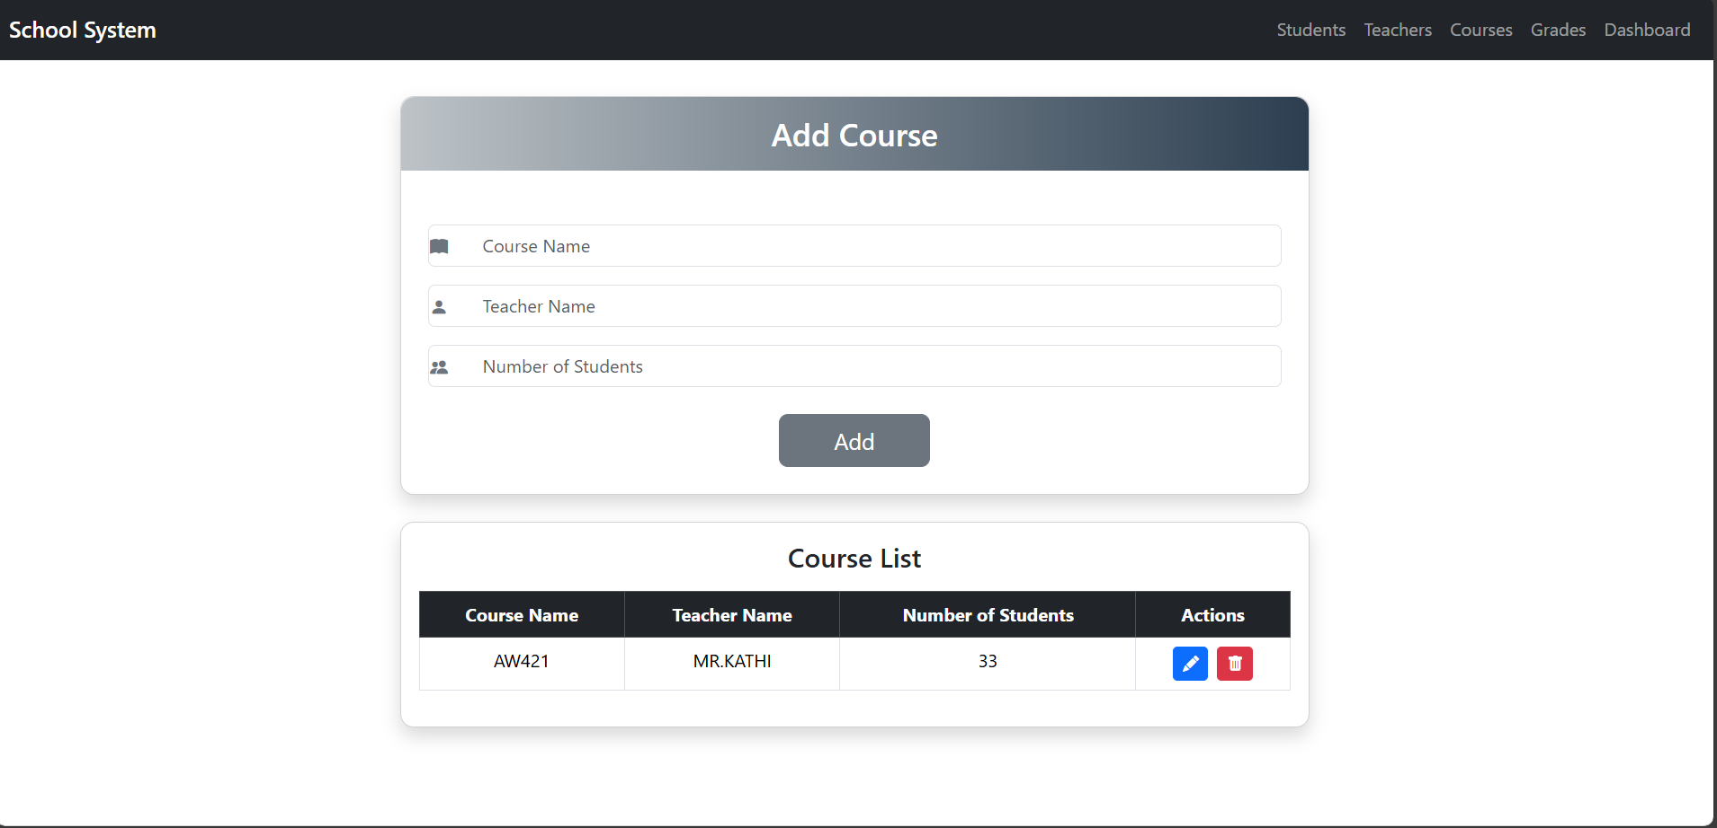
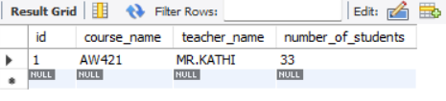

Design Outline
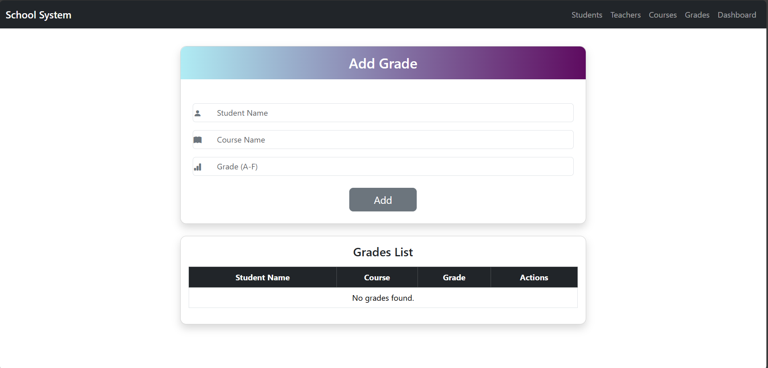

Output (Example)
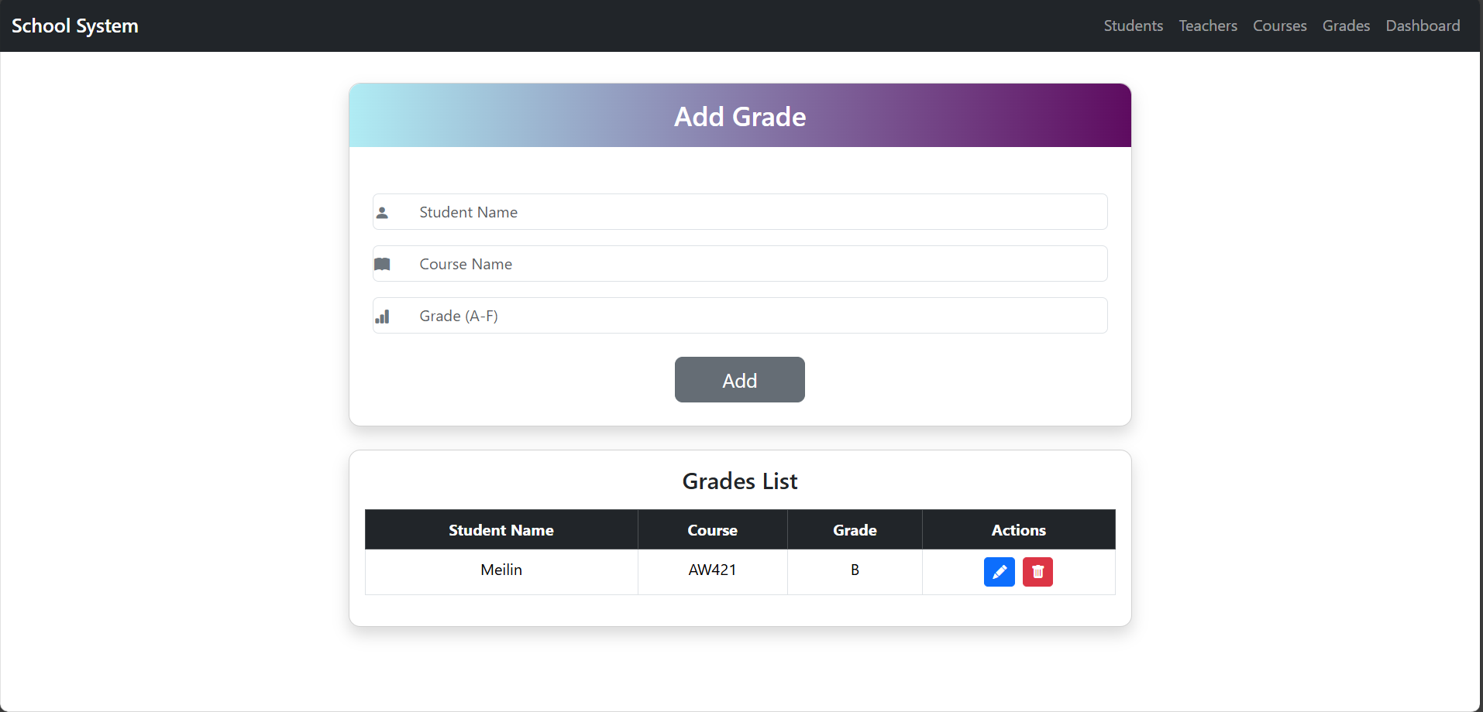
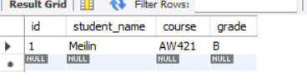

Dashboard (Example)
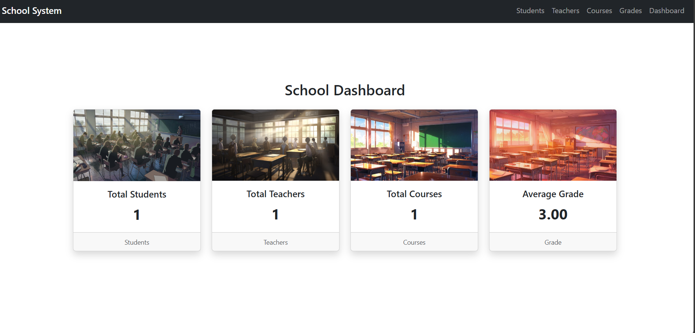

Validation example
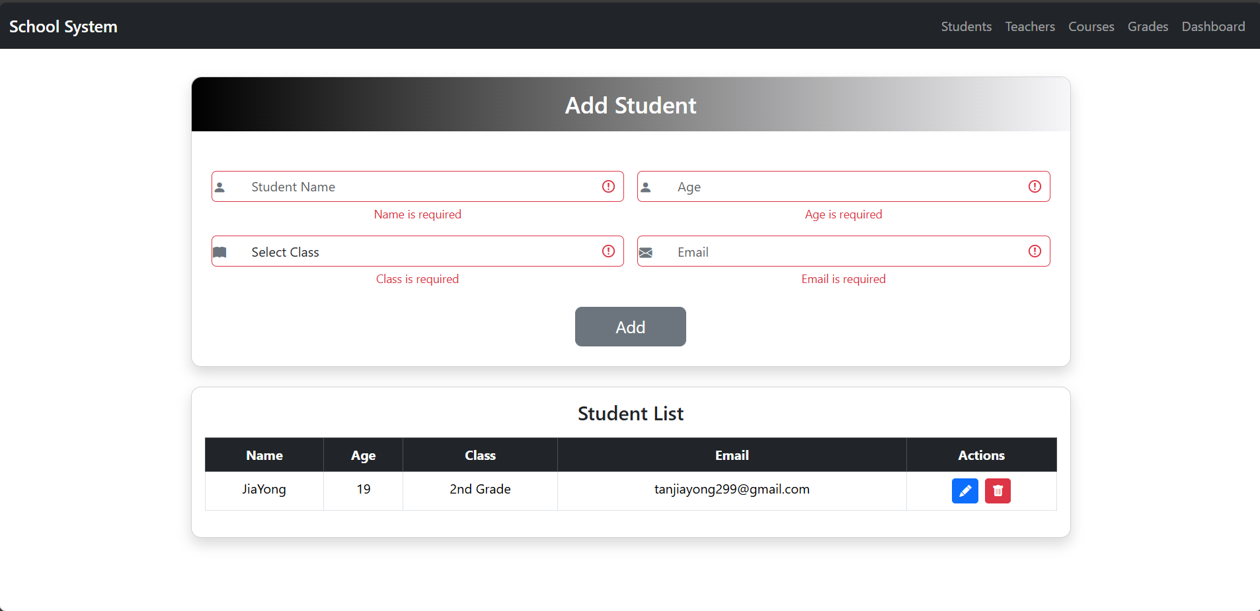

Edit(update) example
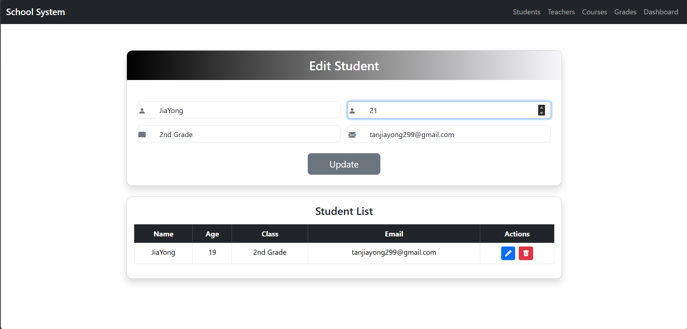
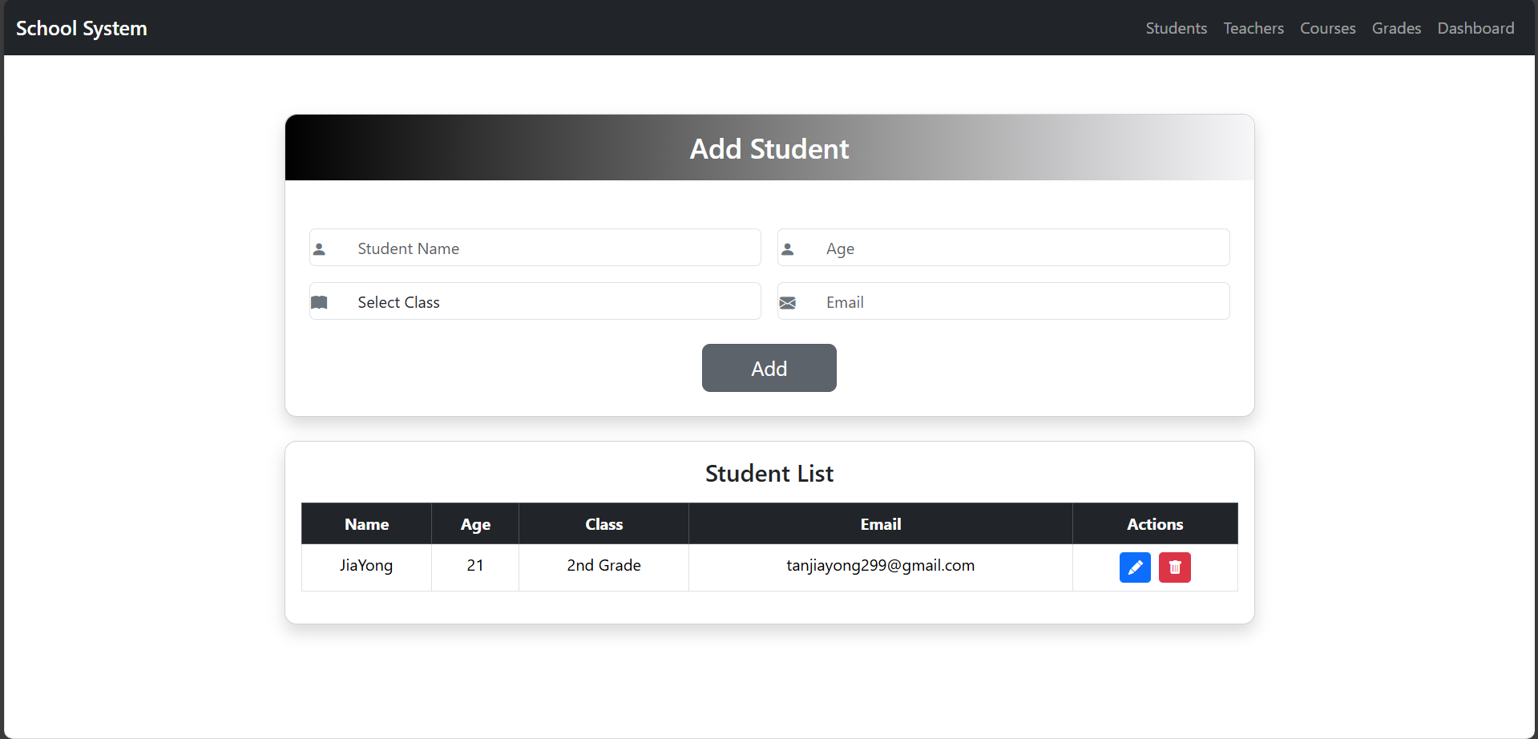

Delete example
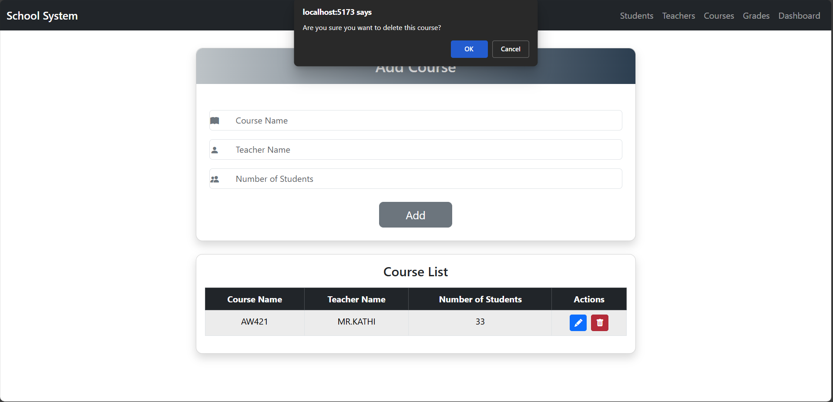
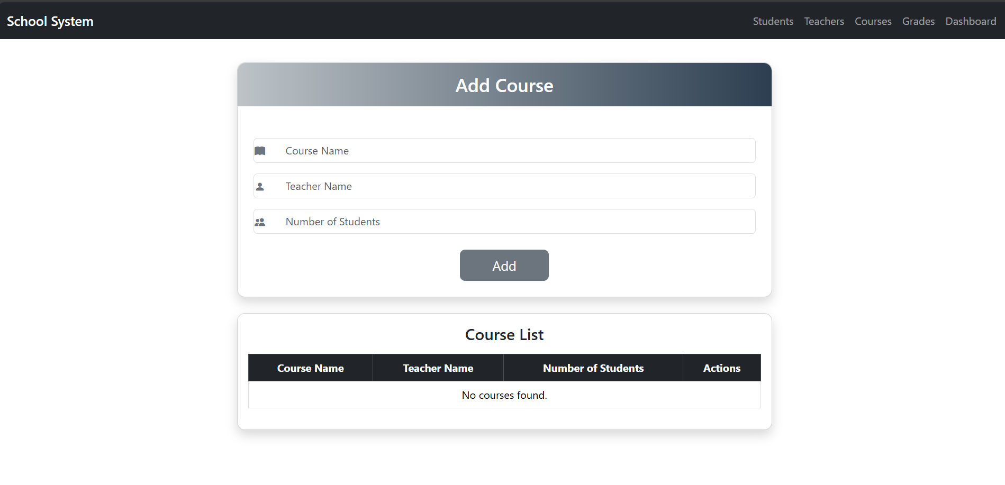

Development Coding

import { useState, useEffect } from 'react';
import axios from 'axios';
import { Formik, Form, Field, ErrorMessage } from 'formik';
import * as Yup from 'yup';
import './App.css';
import 'bootstrap/dist/css/bootstrap.min.css';
import 'bootstrap-icons/font/bootstrap-icons.css';
import { Link } from 'react-router-dom';
// At the top of your App.js or index.js
import 'bootstrap/dist/js/bootstrap.bundle.min.js';

// Allowed classes
const allowedClasses = ["1st Grade", "2nd Grade", "3rd Grade", "4th Grade", "5th Grade"];

const validationSchema = Yup.object({
name: Yup.string()
.required('Name is required')
.min(3, 'Name must be at least 3 characters'),

age: Yup.number()
.required('Age is required')
.min(5, 'Age must be between 5 and 100')
.max(100, 'Age must be between 5 and 100'),

student_class: Yup.string()
.required('Class is required')
.oneOf(allowedClasses, 'Class must be a valid class (e.g., "1st Grade")'),

email: Yup.string()
.email('Invalid email format')
.required('Email is required'),
});

function StudentListTable() {
const [students, setStudents] = useState([]);
const [editingIndex, setEditingIndex] = useState(null);

useEffect(() => {
fetchStudents();
}, []);

const fetchStudents = async () => {
try {
const res = await axios.get('http://localhost:3001/students');
setStudents(res.data);
} catch (error) {
console.error('Failed to fetch students:', error);
}
};

const handleSubmit = async (values, { resetForm }) => {
try {
if (editingIndex !== null) {
const studentId = students[editingIndex].id;
await axios.put(`http://localhost:3001/students/${studentId}`, values);
setEditingIndex(null);
} else {
await axios.post('http://localhost:3001/students', values);
}
fetchStudents();
resetForm();
} catch (error) {
console.error('Failed to save student:', error);
alert('Failed to save student.');
}
};

const handleEdit = (index) => {
setEditingIndex(index);
};

const handleDelete = async (index) => {
if (!window.confirm('Are you sure you want to delete this student?')) return;
try {
const studentId = students[index].id;
await axios.delete(`http://localhost:3001/students/${studentId}`);
fetchStudents();
} catch (error) {
console.error('Failed to delete student:', error);
alert('Failed to delete student.');
}
};

return (
<div>
<nav className="navbar navbar-expand-lg navbar-dark bg-dark fixed-top">
<div className="container-fluid">
<Link className="navbar-brand" to="/">School System</Link>
<button
className="navbar-toggler"
type="button"
data-bs-toggle="collapse"
data-bs-target="#navbarNav"
>
<span className="navbar-toggler-icon"></span>
</button>
<div className="collapse navbar-collapse" id="navbarNav">
<ul className="navbar-nav ms-auto">
<li className="nav-item">
<Link className="nav-link" to="/">Students</Link>
</li>
<li className="nav-item">
<Link className="nav-link" to="/teacher">Teachers</Link>
</li>
<li className="nav-item">
<Link className="nav-link" to="/course">Courses</Link>
</li>
<li className="nav-item">
<Link className="nav-link" to="/grade">Grades</Link>
</li>
<li className="nav-item">
<Link className="nav-link" to="/dashboard">Dashboard</Link>
</li>
</ul>
</div>
</div>
</nav>

<div className="container my-4">
{/* Student Form */}
<div className="card shadow mb-4" style={{ borderRadius: '12px' }}>
<div
className="text-center py-3 mb-4"
style={{
background: 'linear-gradient(to right, #000000ff, #f7f7f9ff)',
color: 'white',
borderTopLeftRadius: '12px',
borderTopRightRadius: '12px',
}}
>
<h3 className="mb-0">{editingIndex !== null ? 'Edit Student' : 'Add Student'}</h3>
</div>

<Formik
enableReinitialize
initialValues={
editingIndex !== null
? students[editingIndex]
: { name: '', age: '', student_class: '', email: '' }
}
validationSchema={validationSchema}
onSubmit={handleSubmit}
>
{({ errors, touched }) => (
<Form className="p-4">
<div className="row g-3">
{/* Name */}
<div className="col-md-6 d-flex flex-column position-relative">
<i
className="bi bi-person-fill position-absolute"
style={{
top: '20px',
left: '10px',
transform: 'translateY(-50%)',
color: '#6c757d',
}}
></i>
<Field
type="text"
name="name"
className={`form-control ps-5 ${
errors.name && touched.name ? 'is-invalid' : ''
}`}
placeholder="Student Name"
/>
<ErrorMessage
name="name"
component="div"
className="invalid-feedback"
/>
</div>

{/* Age */}
<div className="col-md-6 d-flex flex-column position-relative">
<i
className="bi bi-person-fill position-absolute"
style={{
top: '20px',
left: '10px',
transform: 'translateY(-50%)',
color: '#6c757d',
}}
></i>
<Field
type="number"
name="age"
className={`form-control ps-5 ${
errors.age && touched.age ? 'is-invalid' : ''
}`}
placeholder="Age"
/>
<ErrorMessage
name="age"
component="div"
className="invalid-feedback"
/>
</div>

{/* Class */}
<div className="col-md-6 d-flex flex-column position-relative">
<i
className="bi bi-book-fill position-absolute"
style={{
top: '20px',
left: '10px',
transform: 'translateY(-50%)',
color: '#6c757d',
}}
></i>
<Field
as="select"
name="student_class"
className={`form-control ps-5 ${
errors.student_class && touched.student_class ? 'is-invalid' : ''
}`}
>
<option value="">Select Class</option>
{allowedClasses.map((cls) => (
<option key={cls} value={cls}>
{cls}
</option>
))}
</Field>
<ErrorMessage
name="student_class"
component="div"
className="invalid-feedback"
/>
</div>

{/* Email */}
<div className="col-md-6 d-flex flex-column position-relative">
<i
className="bi bi-envelope-fill position-absolute"
style={{
top: '20px',
left: '10px',
transform: 'translateY(-50%)',
color: '#6c757d',
}}
></i>
<Field
type="email"
name="email"
className={`form-control ps-5 ${
errors.email && touched.email ? 'is-invalid' : ''
}`}
placeholder="Email"
/>
<ErrorMessage
name="email"
component="div"
className="invalid-feedback"
/>
</div>
</div>

<div className="d-flex justify-content-center mt-4">
<button type="submit" className="btn btn-secondary btn-lg px-5">
{editingIndex !== null ? 'Update' : 'Add'}
</button>
</div>
</Form>
)}
</Formik>
</div>

{/* Student Table */}
<div className="card shadow" style={{ borderRadius: '12px' }}>
<div className="card-body">
<h4 className="card-title mb-3">Student List</h4>
<div className="table-responsive">
<table className="table table-bordered table-hover">
<thead className="table-dark">
<tr>
<th>Name</th>
<th>Age</th>
<th>Class</th>
<th>Email</th>
<th>Actions</th>
</tr>
</thead>
<tbody>
{students.length === 0 ? (
<tr>
<td colSpan="5" className="text-center">
No students found.
</td>
</tr>
) : (
students.map((student, index) => (
<tr key={student.id}>
<td>{student.name}</td>
<td>{student.age}</td>
<td>{student.student_class}</td>
<td>{student.email}</td>
<td>
<button
className="btn btn-sm btn-primary me-2"
onClick={() => handleEdit(index)}
>
<i className="bi bi-pencil-fill"></i>
</button>
<button
className="btn btn-sm btn-danger"
onClick={() => handleDelete(index)}
>
<i className="bi bi-trash-fill"></i>
</button>
</td>
</tr>
))
)}
</tbody>
</table>
</div>
</div>
</div>
</div>
</div>
);
}

export default StudentListTable;

import { useState, useEffect } from 'react';
import { Link, useNavigate } from 'react-router-dom'; // <-- for navigation
import axios from 'axios';
import { Formik, Form, Field, ErrorMessage } from 'formik';
import * as Yup from 'yup';
import './App.css';
import 'bootstrap/dist/css/bootstrap.min.css';
import 'bootstrap-icons/font/bootstrap-icons.css';
import 'bootstrap/dist/js/bootstrap.bundle.min.js';

// Yup validation schema for teachers
const validationSchema = Yup.object({
name: Yup.string().required('Name is required').min(3, 'Name must be at least 3 characters'),
subject: Yup.string().required('Subject is required'),
email: Yup.string().email('Invalid email format').required('Email is required'),
});

function TeacherListTable() {
const [teachers, setTeachers] = useState([]);
const [editingIndex, setEditingIndex] = useState(null);

useEffect(() => {
fetchTeachers();
}, []);

const fetchTeachers = async () => {
try {
const res = await axios.get('http://localhost:3001/teachers');
setTeachers(res.data);
} catch (error) {
console.error('Failed to fetch teachers:', error);
}
};

const handleSubmit = async (values, { resetForm }) => {
try {
if (editingIndex !== null) {
const teacherId = teachers[editingIndex].id;
await axios.put(`http://localhost:3001/teachers/${teacherId}`, values);
setEditingIndex(null);
} else {
await axios.post('http://localhost:3001/teachers', values);
}
fetchTeachers();
resetForm();
} catch (error) {
console.error('Failed to save teacher:', error);
alert('Failed to save teacher.');
}
};

const handleEdit = (index) => setEditingIndex(index);

const handleDelete = async (index) => {
if (!window.confirm('Are you sure you want to delete this teacher?')) return;
try {
const teacherId = teachers[index].id;
await axios.delete(`http://localhost:3001/teachers/${teacherId}`);
fetchTeachers();
} catch (error) {
console.error('Failed to delete teacher:', error);
alert('Failed to delete teacher.');
}
};

return (
<div>
<nav className="navbar navbar-expand-lg navbar-dark bg-dark fixed-top">
<div className="container-fluid">
<Link className="navbar-brand" to="/">School System</Link>
<button
className="navbar-toggler"
type="button"
data-bs-toggle="collapse"
data-bs-target="#navbarNav"
>
<span className="navbar-toggler-icon"></span>
</button>
<div className="collapse navbar-collapse" id="navbarNav">
<ul className="navbar-nav ms-auto">
<li className="nav-item">
<Link className="nav-link" to="/">Students</Link>
</li>
<li className="nav-item">
<Link className="nav-link" to="/teacher">Teachers</Link>
</li>
<li className="nav-item">
<Link className="nav-link" to="/course">Course</Link>
</li>
<li className="nav-item">
<Link className="nav-link" to="/grade">Grade</Link>
</li>
<li className="nav-item">
<Link className="nav-link" to="/dashboard">Dashboard</Link>
</li>
</ul>
</div>
</div>
</nav>

{/* --- Teacher Form --- */}
<div className="container my-4">
<div className="card shadow mb-4" style={{ borderRadius: '12px' }}>
<div
className="text-center py-3 mb-4"
style={{
background: 'linear-gradient(to right, #000000, #1e3c72, #2a5298)',
color: 'white',
borderTopLeftRadius: '12px',
borderTopRightRadius: '12px',
}}
>
<h3 className="mb-0">{editingIndex !== null ? 'Edit Teacher' : 'Add Teacher'}</h3>
</div>

<Formik
enableReinitialize
initialValues={
editingIndex !== null
? teachers[editingIndex]
: { name: '', subject: '', email: '' }
}
validationSchema={validationSchema}
onSubmit={handleSubmit}
>
{({ errors, touched }) => (
<Form className="p-4">
<div className="row g-3">
{/* Name */}
<div className="col-md-12 d-flex flex-column position-relative">
<i
className="bi bi-person-fill position-absolute"
style={{
top: '20px',
left: '10px',
transform: 'translateY(-50%)',
color: '#6c757d',
}}
></i>
<Field
type="text"
name="name"
className={`form-control ps-5 ${errors.name && touched.name ? 'is-invalid' : ''}`}
placeholder="Teacher Name"
/>
<ErrorMessage name="name" component="div" className="invalid-feedback" />
</div>

{/* Subject */}
<div className="col-md-12 d-flex flex-column position-relative">
<i
className="bi bi-book-fill position-absolute"
style={{
top: '20px',
left: '10px',
transform: 'translateY(-50%)',
color: '#6c757d',
}}
></i>
<Field
type="text"
name="subject"
className={`form-control ps-5 ${errors.subject && touched.subject ? 'is-invalid' : ''}`}
placeholder="Subject"
/>
<ErrorMessage name="subject" component="div" className="invalid-feedback" />
</div>

{/* Email */}
<div className="col-md-12 d-flex flex-column position-relative">
<i
className="bi bi-envelope-fill position-absolute"
style={{
top: '20px',
left: '10px',
transform: 'translateY(-50%)',
color: '#6c757d',
}}
></i>
<Field
type="email"
name="email"
className={`form-control ps-5 ${errors.email && touched.email ? 'is-invalid' : ''}`}
placeholder="Email"
/>
<ErrorMessage name="email" component="div" className="invalid-feedback" />
</div>
</div>

<div className="d-flex justify-content-center mt-4">
<button type="submit" className="btn btn-secondary btn-lg px-5">
{editingIndex !== null ? 'Update' : 'Add'}
</button>
</div>
</Form>
)}
</Formik>
</div>

{/* --- Teacher Table --- */}
<div className="card shadow" style={{ borderRadius: '12px' }}>
<div className="card-body">
<h4 className="card-title mb-3">Teacher List</h4>
<div className="table-responsive">
<table className="table table-bordered table-hover">
<thead className="table-dark">
<tr>
<th>Name</th>
<th>Subject</th>
<th>Email</th>
<th>Actions</th>
</tr>
</thead>
<tbody>
{teachers.length === 0 ? (
<tr>
<td colSpan="4" className="text-center">No teachers found.</td>
</tr>
) : (
teachers.map((teacher, index) => (
<tr key={teacher.id}>
<td>{teacher.name}</td>
<td>{teacher.subject}</td>
<td>{teacher.email}</td>
<td>
<button
className="btn btn-sm btn-primary me-2"
onClick={() => handleEdit(index)}
>
<i className="bi bi-pencil-fill"></i>
</button>
<button
className="btn btn-sm btn-danger"
onClick={() => handleDelete(index)}
>
<i className="bi bi-trash-fill"></i>
</button>
</td>
</tr>
))
)}
</tbody>
</table>
</div>
</div>
</div>
</div>
</div>
);
}

export default TeacherListTable;

import { useState, useEffect } from 'react';
import axios from 'axios';
import { Formik, Form, Field, ErrorMessage } from 'formik';
import * as Yup from 'yup';
import './App.css';
import 'bootstrap/dist/css/bootstrap.min.css';
import 'bootstrap-icons/font/bootstrap-icons.css';
import { Link } from 'react-router-dom';
// At the top of your App.js or index.js
import 'bootstrap/dist/js/bootstrap.bundle.min.js';

const validationSchema = Yup.object({
course_name: Yup.string()
.required('Course Name is required'),

teacher_name: Yup.string()
.required('Teacher Name is required')
.min(3, 'Teacher Name must be at least 3 characters'),

number_of_students: Yup.number()
.required('Number of Students is required')
.integer('Number of Students must be an integer')
.min(1, 'There must be at least 1 student')
});

function CourseListTable() {
const [courses, setCourses] = useState([]);
const [editingIndex, setEditingIndex] = useState(null);

useEffect(() => {
fetchCourses();
}, []);

const fetchCourses = async () => {
try {
const res = await axios.get('http://localhost:3001/courses');
setCourses(res.data);
} catch (error) {
console.error('Failed to fetch courses:', error);
}
};

const handleSubmit = async (values, { resetForm }) => {
try {
if (editingIndex !== null) {
const courseId = courses[editingIndex].id;
await axios.put(`http://localhost:3001/courses/${courseId}`, values);
setEditingIndex(null);
} else {
await axios.post('http://localhost:3001/courses', values);
}
fetchCourses();
resetForm();
} catch (error) {
console.error('Failed to save course:', error);
alert('Failed to save course.');
}
};

const handleEdit = (index) => {
setEditingIndex(index);
};

const handleDelete = async (index) => {
if (!window.confirm('Are you sure you want to delete this course?')) return;
try {
const courseId = courses[index].id;
await axios.delete(`http://localhost:3001/courses/${courseId}`);
fetchCourses();
} catch (error) {
console.error('Failed to delete course:', error);
alert('Failed to delete course.');
}
};

return (
<div>
<nav className="navbar navbar-expand-lg navbar-dark bg-dark fixed-top">
<div className="container-fluid">
<Link className="navbar-brand" to="/">School System</Link>
<button
className="navbar-toggler"
type="button"
data-bs-toggle="collapse"
data-bs-target="#navbarNav"
>
<span className="navbar-toggler-icon"></span>
</button>
<div className="collapse navbar-collapse" id="navbarNav">
<ul className="navbar-nav ms-auto">
<li className="nav-item">
<Link className="nav-link" to="/">Students</Link>
</li>
<li className="nav-item">
<Link className="nav-link" to="/teacher">Teachers</Link>
</li>
<li className="nav-item">
<Link className="nav-link" to="/course">Courses</Link>
</li>
<li className="nav-item">
<Link className="nav-link" to="/grade">Grades</Link>
</li>
<li className="nav-item">
<Link className="nav-link" to="/dashboard">Dashboard</Link>
</li>
</ul>
</div>
</div>
</nav>

<div className="container my-4">
{/* Course Form */}
<div className="card shadow mb-4" style={{ borderRadius: '12px' }}>
<div
className="text-center py-3 mb-4"
style={{
background: 'linear-gradient(to right, #bdc3c7, #2c3e50)',
color: 'white',
borderTopLeftRadius: '12px',
borderTopRightRadius: '12px',
}}
>
<h3 className="mb-0">{editingIndex !== null ? 'Edit Course' : 'Add Course'}</h3>
</div>

<Formik
enableReinitialize
initialValues={
editingIndex !== null
? courses[editingIndex]
: { course_name: '', teacher_name: '', number_of_students: '' }
}
validationSchema={validationSchema}
onSubmit={handleSubmit}
>
{({ errors, touched }) => (
<Form className="p-4">
<div className="row g-3">
{/* Course Name */}
<div className="col-md-12 d-flex flex-column position-relative">
<i
className="bi bi-book-fill position-absolute"
style={{
top: '20px',
left: '10px',
transform: 'translateY(-50%)',
color: '#6c757d',
}}
></i>
<Field
type="text"
name="course_name"
className={`form-control ps-5 ${
errors.course_name && touched.course_name ? 'is-invalid' : ''
}`}
placeholder="Course Name"
/>
<ErrorMessage name="course_name" component="div" className="invalid-feedback" />
</div>

{/* Teacher Name */}
<div className="col-md-12 d-flex flex-column position-relative">
<i
className="bi bi-person-fill position-absolute"
style={{
top: '20px',
left: '10px',
transform: 'translateY(-50%)',
color: '#6c757d',
}}
></i>
<Field
type="text"
name="teacher_name"
className={`form-control ps-5 ${
errors.teacher_name && touched.teacher_name ? 'is-invalid' : ''
}`}
placeholder="Teacher Name"
/>
<ErrorMessage name="teacher_name" component="div" className="invalid-feedback" />
</div>

{/* Number of Students */}
<div className="col-md-12 d-flex flex-column position-relative">
<i
className="bi bi-people-fill position-absolute"
style={{
top: '20px',
left: '10px',
transform: 'translateY(-50%)',
color: '#6c757d',
}}
></i>
<Field
type="number"
name="number_of_students"
className={`form-control ps-5 ${
errors.number_of_students && touched.number_of_students ? 'is-invalid' : ''
}`}
placeholder="Number of Students"
/>
<ErrorMessage name="number_of_students" component="div" className="invalid-feedback" />
</div>
</div>

<div className="d-flex justify-content-center mt-4">
<button type="submit" className="btn btn-secondary btn-lg px-5">
{editingIndex !== null ? 'Update' : 'Add'}
</button>
</div>
</Form>
)}
</Formik>
</div>

{/* Course Table */}
<div className="card shadow" style={{ borderRadius: '12px' }}>
<div className="card-body">
<h4 className="card-title mb-3">Course List</h4>
<div className="table-responsive">
<table className="table table-bordered table-hover">
<thead className="table-dark">
<tr>
<th>Course Name</th>
<th>Teacher Name</th>
<th>Number of Students</th>
<th>Actions</th>
</tr>
</thead>
<tbody>
{courses.length === 0 ? (
<tr>
<td colSpan="4" className="text-center">No courses found.</td>
</tr>
) : (
courses.map((course, index) => (
<tr key={course.id}>
<td>{course.course_name}</td>
<td>{course.teacher_name}</td>
<td>{course.number_of_students}</td>
<td>
<button
className="btn btn-sm btn-primary me-2"
onClick={() => handleEdit(index)}
>
<i className="bi bi-pencil-fill"></i>
</button>
<button
className="btn btn-sm btn-danger"
onClick={() => handleDelete(index)}
>
<i className="bi bi-trash-fill"></i>
</button>
</td>
</tr>
))
)}
</tbody>
</table>
</div>
</div>
</div>
</div>
</div>
);
}

export default CourseListTable;

import { useState, useEffect } from 'react';
import axios from 'axios';
import { Formik, Form, Field, ErrorMessage } from 'formik';
import * as Yup from 'yup';
import './App.css';
import 'bootstrap/dist/css/bootstrap.min.css';
import 'bootstrap-icons/font/bootstrap-icons.css';
import { Link } from 'react-router-dom';
// At the top of your App.js or index.js
import 'bootstrap/dist/js/bootstrap.bundle.min.js';

// Yup validation schema for grades
const validationSchema = Yup.object({
student_name: Yup.string()
.required('Student name is required')
.min(3, 'Student name must be at least 3 characters'),

course: Yup.string()
.required('Course is required')
.min(2, 'Course must be at least 2 characters'),

grade: Yup.string()
.required('Grade is required')
.matches(/^[A-F]$/, 'Grade must be between A and F'),
});

function GradeManagement() {
const [grades, setGrades] = useState([]);
const [editingIndex, setEditingIndex] = useState(null);

useEffect(() => {
fetchGrades();
}, []);

const fetchGrades = async () => {
try {
const res = await axios.get('http://localhost:3001/grades');
setGrades(res.data);
} catch (error) {
console.error('Failed to fetch grades:', error);
}
};

const handleSubmit = async (values, { resetForm }) => {
try {
if (editingIndex !== null) {
const gradeId = grades[editingIndex].id;
await axios.put(`http://localhost:3001/grades/${gradeId}`, values);
setEditingIndex(null);
} else {
await axios.post('http://localhost:3001/grades', values);
}
fetchGrades();
resetForm();
} catch (error) {
console.error('Failed to save grade:', error);
alert('Failed to save grade.');
}
};

const handleEdit = (index) => {
setEditingIndex(index);
};

const handleDelete = async (index) => {
if (!window.confirm('Are you sure you want to delete this grade?')) return;
try {
const gradeId = grades[index].id;
await axios.delete(`http://localhost:3001/grades/${gradeId}`);
fetchGrades();
} catch (error) {
console.error('Failed to delete grade:', error);
alert('Failed to delete grade.');
}
};

return (

<div>
<nav className="navbar navbar-expand-lg navbar-dark bg-dark fixed-top">
<div className="container-fluid">
<Link className="navbar-brand" to="/">School System</Link>
<button
className="navbar-toggler"
type="button"
data-bs-toggle="collapse"
data-bs-target="#navbarNav"
>
<span className="navbar-toggler-icon"></span>
</button>
<div className="collapse navbar-collapse" id="navbarNav">
<ul className="navbar-nav ms-auto">
<li className="nav-item">
<Link className="nav-link" to="/">Students</Link>
</li>
<li className="nav-item">
<Link className="nav-link" to="/teacher">Teachers</Link>
</li>
<li className="nav-item">
<Link className="nav-link" to="/course">Courses</Link>
</li>
<li className="nav-item">
<Link className="nav-link" to="/grade">Grades</Link>
</li>
<li className="nav-item">
<Link className="nav-link" to="/dashboard">Dashboard</Link>
</li>
</ul>
</div>
</div>
</nav>

<div className="container my-4">
{/* Grade Form */}
<div className="card shadow mb-4" style={{ borderRadius: '12px' }}>
<div
className="text-center py-3 mb-4"
style={{
background: 'linear-gradient(to right, #b0ecf4ff, #5e0b60ff)',
color: 'white',
borderTopLeftRadius: '12px',
borderTopRightRadius: '12px',
}}
>
<h3 className="mb-0">{editingIndex !== null ? 'Edit Grade' : 'Add Grade'}</h3>
</div>

<Formik
enableReinitialize
initialValues={
editingIndex !== null
? grades[editingIndex]
: { student_name: '', course: '', grade: '' }
}
validationSchema={validationSchema}
onSubmit={handleSubmit}
>
{({ errors, touched }) => (
<Form className="p-4">
<div className="row g-3">
{/* Student Name */}
<div className="col-md-12 d-flex flex-column position-relative">
<i
className="bi bi-person-fill position-absolute"
style={{
top: '20px',
left: '10px',
transform: 'translateY(-50%)',
color: '#6c757d',
}}
></i>
<Field
type="text"
name="student_name"
className={`form-control ps-5 ${
errors.student_name && touched.student_name ? 'is-invalid' : ''
}`}
placeholder="Student Name"
/>
<ErrorMessage name="student_name" component="div" className="invalid-feedback" />
</div>

{/* Course */}
<div className="col-md-12 d-flex flex-column position-relative">
<i
className="bi bi-book-fill position-absolute"
style={{
top: '20px',
left: '10px',
transform: 'translateY(-50%)',
color: '#6c757d',
}}
></i>
<Field
type="text"
name="course"
className={`form-control ps-5 ${
errors.course && touched.course ? 'is-invalid' : ''
}`}
placeholder="Course Name"
/>
<ErrorMessage name="course" component="div" className="invalid-feedback" />
</div>

{/* Grade */}
<div className="col-md-12 d-flex flex-column position-relative">
<i
className="bi bi-bar-chart-fill position-absolute"
style={{
top: '20px',
left: '10px',
transform: 'translateY(-50%)',
color: '#6c757d',
}}
></i>
<Field
type="text"
name="grade"
className={`form-control ps-5 ${
errors.grade && touched.grade ? 'is-invalid' : ''
}`}
placeholder="Grade (A-F)"
/>
<ErrorMessage name="grade" component="div" className="invalid-feedback" />
</div>
</div>

<div className="d-flex justify-content-center mt-4">
<button type="submit" className="btn btn-secondary btn-lg px-5">
{editingIndex !== null ? 'Update' : 'Add'}
</button>
</div>
</Form>
)}
</Formik>
</div>

{/* Grades Table */}
<div className="card shadow" style={{ borderRadius: '12px' }}>
<div className="card-body">
<h4 className="card-title mb-3">Grades List</h4>
<div className="table-responsive">
<table className="table table-bordered table-hover">
<thead className="table-dark">
<tr>
<th>Student Name</th>
<th>Course</th>
<th>Grade</th>
<th>Actions</th>
</tr>
</thead>
<tbody>
{grades.length === 0 ? (
<tr>
<td colSpan="4" className="text-center">No grades found.</td>
</tr>
) : (
grades.map((grade, index) => (
<tr key={grade.id}>
<td>{grade.student_name}</td>
<td>{grade.course}</td>
<td>{grade.grade}</td>
<td>
<button className="btn btn-sm btn-primary me-2" onClick={() => handleEdit(index)}>
<i className="bi bi-pencil-fill"></i>
</button>
<button className="btn btn-sm btn-danger" onClick={() => handleDelete(index)}>
<i className="bi bi-trash-fill"></i>
</button>
</td>
</tr>
))
)}
</tbody>
</table>
</div>
</div>
</div>
</div>
</div>
);
}

export default GradeManagement;

import { useState, useEffect } from 'react';
import axios from 'axios';
import './App.css';
import 'bootstrap/dist/css/bootstrap.min.css';
import 'bootstrap-icons/font/bootstrap-icons.css';
import { Link } from 'react-router-dom';
import 'bootstrap/dist/js/bootstrap.bundle.min.js';

function Dashboard() {
const [totalStudents, setTotalStudents] = useState(0);
const [totalTeachers, setTotalTeachers] = useState(0);
const [totalCourses, setTotalCourses] = useState(0);
const [averageGrade, setAverageGrade] = useState('0.00');

useEffect(() => {
const fetchData = async () => {
try {
const studentRes = await axios.get('http://localhost:3001/students/count');
setTotalStudents(studentRes.data.total);

const teacherRes = await axios.get('http://localhost:3001/teachers/count');
setTotalTeachers(teacherRes.data.total);

const courseRes = await axios.get('http://localhost:3001/courses/count');
setTotalCourses(courseRes.data.total);

const gradeRes = await axios.get('http://localhost:3001/grades/average');
console.log(gradeRes.data);

const avg = gradeRes.data.avg_grade;
setAverageGrade(avg !== null ? Number(avg).toFixed(2) : '0.00'); // safe fallback

} catch (error) {
console.error('Failed to fetch dashboard data:', error);
}
};

fetchData();
}, []);

return (

<div>
<nav className="navbar navbar-expand-lg navbar-dark bg-dark fixed-top">
<div className="container-fluid">
<Link className="navbar-brand" to="/">School System</Link>
<button
className="navbar-toggler"
type="button"
data-bs-toggle="collapse"
data-bs-target="#navbarNav"
>
<span className="navbar-toggler-icon"></span>
</button>
<div className="collapse navbar-collapse" id="navbarNav">
<ul className="navbar-nav ms-auto">
<li className="nav-item">
<Link className="nav-link" to="/">Students</Link>
</li>
<li className="nav-item">
<Link className="nav-link" to="/teacher">Teachers</Link>
</li>
<li className="nav-item">
<Link className="nav-link" to="/course">Courses</Link>
</li>
<li className="nav-item">
<Link className="nav-link" to="/grade">Grades</Link>
</li>
<li className="nav-item">
<Link className="nav-link" to="/dashboard">Dashboard</Link>
</li>
</ul>
</div>
</div>
</nav>

<div className="container my-5">
<h2 className="mb-4">School Dashboard</h2>
<div className="row row-cols-1 row-cols-md-4 g-4">

{/* Total Students */}
<div className="col">
<div className="card h-100 shadow">
<img src="students.png" className="card-img-top" alt="Students" />
<div className="card-body text-center">
<h5 className="card-title">Total Students</h5>
<p className="card-text">
<strong style={{ fontSize: "2rem" }}>{totalStudents}</strong>
</p>
</div>
<div className="card-footer text-center">
<small className="text-muted">Students</small>
</div>
</div>
</div>

{/* Total Teachers */}
<div className="col">
<div className="card h-100 shadow">
<img src="teachers.png" className="card-img-top" alt="Teachers" />
<div className="card-body text-center">
<h5 className="card-title">Total Teachers</h5>
<p className="card-text">
<strong style={{ fontSize: "2rem" }}>{totalTeachers}</strong>
</p>
</div>
<div className="card-footer text-center">
<small className="text-muted">Teachers</small>
</div>
</div>
</div>

{/* Total Courses */}
<div className="col">
<div className="card h-100 shadow">
<img src="courses.png" className="card-img-top" alt="Courses" />
<div className="card-body text-center">
<h5 className="card-title">Total Courses</h5>
<p className="card-text">
<strong style={{ fontSize: "2rem" }}>{totalCourses}</strong>
</p>
</div>
<div className="card-footer text-center">
<small className="text-muted">Courses</small>
</div>
</div>
</div>

{/* Average Grade */}
<div className="col">
<div className="card h-100 shadow">
<img src="grade.png" className="card-img-top" alt="Grade" />
<div className="card-body text-center">
<h5 className="card-title">Average Grade</h5>
<p className="card-text">
<strong style={{ fontSize: "2rem" }}>{averageGrade}</strong>
</p>
</div>
<div className="card-footer text-center">
<small className="text-muted">Grade</small>
</div>
</div>
</div>
</div>
</div>
</div>

);
}

export default Dashboard;

SERVERAll.cjs

// serverStudent.cjs
const express = require('express');
const mysql = require('mysql2');
const cors = require('cors');
const bodyParser = require('body-parser');

const app = express();
app.use(cors());
app.use(bodyParser.json());

// MySQL connection
const db = mysql.createConnection({
host: 'localhost',
user: 'root',
password: 'passwd', // change to your MySQL password
database: 'projectDB'
});

db.connect(err => {
if (err) console.error('Database connection failed:', err.message);
else console.log('Connected to MySQL (projectDB)');
});

// --- CREATE: Add new student ---
app.post('/students', (req, res) => {
const { name, age, student_class, email } = req.body;
const sql = 'INSERT INTO StudentListTable (name, age, student_class, email) VALUES (?, ?, ?, ?)';
db.query(sql, [name, age, student_class, email], (err, result) => {
if (err) return res.status(500).send('Database error: ' + err.message);
res.send({ message: 'User added successfully', id: result.insertId });
});
});

// --- READ: Get all students ---
app.get('/students', (req, res) => {
const sql = 'SELECT * FROM StudentListTable';
db.query(sql, (err, results) => {
if (err) return res.status(500).send('Database error: ' + err.message);
res.json(results);
});
});

// --- UPDATE: Edit a student ---
app.put('/students/:id', (req, res) => {
const { id } = req.params;
const { name, age, student_class, email } = req.body;
const sql = 'UPDATE StudentListTable SET name=?, age=?, student_class=?, email=? WHERE id=?';
db.query(sql, [name, age, student_class, email, id], (err, result) => {
if (err) return res.status(500).send('Database error: ' + err.message);
res.send({ message: 'User updated successfully' });
});
});

// --- DELETE: Remove a student ---
app.delete('/students/:id', (req, res) => {
const { id } = req.params;
const sql = 'DELETE FROM StudentListTable WHERE id=?';
db.query(sql, [id], (err, result) => {
if (err) return res.status(500).send('Database error: ' + err.message);
res.send({ message: 'User deleted successfully' });
});
});

// --- CREATE: Add new teacher ---
app.post('/teachers', (req, res) => {
const { name, subject, email } = req.body;
const sql = 'INSERT INTO TeacherListTable (name, subject, email) VALUES (?, ?, ?)';
db.query(sql, [name, subject, email], (err, result) => {
if (err) return res.status(500).send({ error: 'Database error: ' + err.message });
res.send({ message: 'Teacher added successfully', id: result.insertId });
});
});

// --- READ: Get all teachers ---
app.get('/teachers', (req, res) => {
const sql = 'SELECT * FROM TeacherListTable';
db.query(sql, (err, results) => {
if (err) return res.status(500).send({ error: 'Database error: ' + err.message });
res.json(results);
});
});

// --- UPDATE: Edit a teacher ---
app.put('/teachers/:id', (req, res) => {
const { id } = req.params;
const { name, subject, email } = req.body;
const sql = 'UPDATE TeacherListTable SET name=?, subject=?, email=? WHERE id=?';
db.query(sql, [name, subject, email, id], (err, result) => {
if (err) return res.status(500).send({ error: 'Database error: ' + err.message });
res.send({ message: 'Teacher updated successfully' });
});
});

// --- DELETE: Remove a teacher ---
app.delete('/teachers/:id', (req, res) => {
const { id } = req.params;
const sql = 'DELETE FROM TeacherListTable WHERE id=?';
db.query(sql, [id], (err, result) => {
if (err) return res.status(500).send({ error: 'Database error: ' + err.message });
res.send({ message: 'Teacher deleted successfully' });
});
});

// --- CREATE: Add new course ---
app.post('/courses', (req, res) => {
const { course_name, teacher_name, number_of_students } = req.body;
const sql = 'INSERT INTO CourseListTable (course_name, teacher_name, number_of_students) VALUES (?, ?, ?)';
db.query(sql, [course_name, teacher_name, number_of_students], (err, result) => {
if (err) return res.status(500).send('Database error: ' + err.message);
res.send({ message: 'Course added successfully', id: result.insertId });
});
});

// --- READ: Get all courses ---
app.get('/courses', (req, res) => {
const sql = 'SELECT * FROM CourseListTable';
db.query(sql, (err, results) => {
if (err) return res.status(500).send('Database error: ' + err.message);
res.json(results);
});
});

// --- UPDATE: Edit a course ---
app.put('/courses/:id', (req, res) => {
const { id } = req.params;
const { course_name, teacher_name, number_of_students } = req.body;
const sql = 'UPDATE CourseListTable SET course_name=?, teacher_name=?, number_of_students=? WHERE id=?';
db.query(sql, [course_name, teacher_name, number_of_students, id], (err, result) => {
if (err) return res.status(500).send('Database error: ' + err.message);
res.send({ message: 'Course updated successfully' });
});
});

// --- DELETE: Remove a course ---
app.delete('/courses/:id', (req, res) => {
const { id } = req.params;
const sql = 'DELETE FROM CourseListTable WHERE id=?';
db.query(sql, [id], (err, result) => {
if (err) return res.status(500).send('Database error: ' + err.message);
res.send({ message: 'Course deleted successfully' });
});
});

// --- CREATE: Add new grade ---
app.post('/grades', (req, res) => {
const { student_name, course, grade } = req.body;
const sql = 'INSERT INTO GradeManagementTable (student_name, course, grade) VALUES (?, ?, ?)';
db.query(sql, [student_name, course, grade], (err, result) => {
if (err) return res.status(500).send('Database error: ' + err.message);
res.send({ message: 'Grade added successfully', id: result.insertId });
});
});

// --- READ: Get all grades ---
app.get('/grades', (req, res) => {
const sql = 'SELECT * FROM GradeManagementTable';
db.query(sql, (err, results) => {
if (err) return res.status(500).send('Database error: ' + err.message);
res.json(results);
});
});

// --- UPDATE: Edit a grade ---
app.put('/grades/:id', (req, res) => {
const { id } = req.params;
const { student_name, course, grade } = req.body;
const sql = 'UPDATE GradeManagementTable SET student_name=?, course=?, grade=? WHERE id=?';
db.query(sql, [student_name, course, grade, id], (err, result) => {
if (err) return res.status(500).send('Database error: ' + err.message);
res.send({ message: 'Grade updated successfully' });
});
});

// --- DELETE: Remove a grade ---
app.delete('/grades/:id', (req, res) => {
const { id } = req.params;
const sql = 'DELETE FROM GradeManagementTable WHERE id=?';
db.query(sql, [id], (err, result) => {
if (err) return res.status(500).send('Database error: ' + err.message);
res.send({ message: 'Grade deleted successfully' });
});
});

// --- GET AVERAGE GRADE --- <-- ADD HERE
app.get('/grades/average', (req, res) => {
const sql = `
SELECT AVG(
CASE grade
WHEN 'A' THEN 4
WHEN 'B' THEN 3
WHEN 'C' THEN 2
WHEN 'D' THEN 1
WHEN 'F' THEN 0
END
) AS avg_grade
FROM GradeManagementTable
`;

db.query(sql, (err, result) => {
if (err) return res.status(500).send("Database error: " + err.message);
res.json(result[0]);
});
});

// Total students
app.get('/students/count', (req, res) => {
db.query('SELECT COUNT(*) AS total FROM StudentListTable', (err, result) => {
if (err) return res.status(500).send(err);
res.json(result[0]);
});
});

// Total teachers
app.get('/teachers/count', (req, res) => {
db.query('SELECT COUNT(*) AS total FROM TeacherListTable', (err, result) => {
if (err) return res.status(500).send(err);
res.json(result[0]);
});
});

// Total courses
app.get('/courses/count', (req, res) => {
db.query('SELECT COUNT(*) AS total FROM CourseListTable', (err, result) => {
if (err) return res.status(500).send(err);
res.json(result[0]);
});
});

// Start server
app.listen(3001, () => console.log('Server running at http://localhost:3001'));

Testing
Test Case | 01
Test Objective | To run the StudentListTable
Test Data | Click to add data into table
Expected Results | Click add to add student
Actual Results | Successfully added student into the table
Conclusion | Actual results meet expected results

Test Case | 02
Test Objective | To run the TeacherListTable
Test Data | Click to add data into table
Expected Results | Click add to add teacher
Actual Results | Successfully added teacher into the table
Conclusion | Actual results meet expected results

Test Case | 03
Test Objective | To run the CourseListTable
Test Data | Click to add data into table
Expected Results | Click add to add course
Actual Results | Successfully added course into the table
Conclusion | Actual results meet expected results

Test Case | 04
Test Objective | To run the GradeManagement
Test Data | Click to add data into table
Expected Results | Click add to add student grade
Actual Results | Successfully added student grade into the table
Conclusion | Actual results meet expected results

Test Case | 05
Test Objective | To run the DashBoard
Test Data | Test the students ,teachers and courses and display average grade is inside the dashboard
Expected Results | Count the students ,teachers and courses in the table and display average grade
Actual Results | Successfully display total number of students, teachers, courses, and average grades.
Conclusion | Actual results meet expected results

Test Case | 06
Test Objective | To run the Validation
Test Data | Test the Validation
Expected Results | If the user doesn't enter any text, display a validation message.
Actual Results | Successfully display a validation when user does not enter any text and example: Student name must be at least 3 characters
Conclusion | Actual results meet expected results

Test Case | 07
Test Objective | Test the edit
Test Data | Test the edit function
Expected Results | Click to update informortion
Actual Results | Successfully update table list
Conclusion | Actual results meet expected results

Test Case | 08
Test Objective | Test the delete
Test Data | Test the delete function
Expected Results | Click OK to delete list
Actual Results | Successfully deleted
Conclusion | Actual results meet expected results

User Guide

Users can access the system through a web browser and navigate the dashboard to manage school data. They can add new records by filling out forms, edit existing information, and delete items they no longer need. All data is displayed in easy-to-read tables, allowing users to quickly view and manage students, teachers, courses, and grades.

Conclusion

The School Information System (SIS) provides an efficient and reliable way to manage school-related data. By digitalizing records of students, teachers, courses, and grades, the system reduces errors and saves time. With its user-friendly ReactJS interface and data validation features, the SIS improves accuracy, accessibility, and overall school management efficiency.

References
ReactJS, “React Documentation,” accessed from https://react.dev/
at 10:00AM on 17/11/2025.

MySQL, “MySQL Developer Documentation,” accessed from https://dev.mysql.com/
at 10:10AM on 17/11/2025.

W3Schools, “HTML, CSS, and JavaScript Tutorials,” accessed from https://www.w3schools.com/
at 10:20AM on 17/11/2025.

GeeksforGeeks, “ReactJS and Web Development Guides,” accessed from https://www.geeksforgeeks.org/
at 10:30AM on 17/11/2025.

MDN Web Docs, “Web Technologies Documentation,” accessed from https://developer.mozilla.org/
at 10:40AM on 17/11/2025.

